- A) The goal of the committee is to achieve maximum employment in the long-run. It has a goal of ensuring the price levels are stable since it seeks to maintain inflation rates as low as 2% in the long run.
b) The committee has a target of having the federal funds at a rate of 0% to ¼ %.
c) The committee seeks to maintain inflation rates as low as 2% in the long run. It plans to allow the inflation rate to be relatively high above the 2% in the short run but be 2% on average and in the long-run.
d) All FOMC members voted for the monetary policy action apart from two, Robert S. Kaplan and Neel Kashkari. Robert Kaplan has an expectation that maintaining the monetary policy at the current rate until there is confidence that the economy can accommodate recent events and gets on track to achieve stable prices and maximum employment. Robert suggests that the committee should maintain greater flexibility on the policy rate beyond the rate they suggested.
Neel Kashkari prefers the committee to indicate an expectation of maintaining current target at the existing range until when core inflation will reach a sustained 2%.

- A)
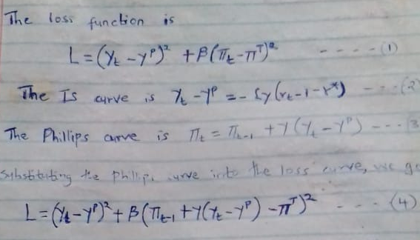

b) Beta = 0.74
- A) There are 20 basis points in one percent.

b) PBOC changed the 7-day of the reverse-repo.

C) Their action was contractionary. The change in the reverse repo is 2.2% to 2.4% which is higher than 2%.

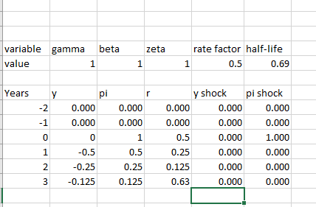
The rate factor = 0.5
The half-life = 0.69

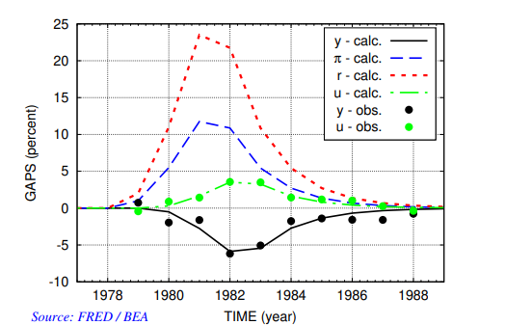
YEARS

- The income is low when pi, the factor rate and unemployment is high.
- Unemployment increases gradually from 1978 to 1983 where it is maximum. It starts to decrease from 1983 to 1989.
- Inflation increases gradually from 1978 to 1981 where it is at the maximum. It decreases after 1981 gradually to 1989. The factor rate increases sharply from 1979 to 1981 where it is the highest. It decreases sharply from 1981 to 1982. It then decreases gradually from 1982 to 1988 where it is constant.

